## Evaluation Result diagram

Class diagram in package 'epo'

1. One of the activities that takes places in the Procurement Procedure life-cycle is the awarding of a contract to one or more Economic Operators, the "Winner(s)".
2. The awards are the result of an assessment process performed by an Evaluation Board. In the case of contest design competitions, the board is formed by a Jury, which decision may be binding for the Procuring Entity (see Evaluation Board Code Type).
3. The awards are notified through a Contract Award Notice, and its publications runs in parallel to the drafting and signature of a Contract.
4. The Contract, in turn, refers to the Awarding Results of the Procurement Procedure, the signatory parties (Procuring Entity and Economic Operator).
5. The Contract may attach other Procurement Documents or other types of Documents.
6. Contracts may specify terms for its management, e.g. conditions and speculations about its renewal.

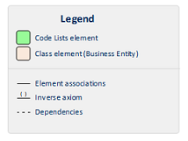

Evaluation Result

Version 1.0

estaromi created on 21/03/2018. Last modified 17/05/2018



1. Evaluation Result